System Requirment Specification (SRS)

Document

“eNeg Negotiation FrameWork”

Content

1.1. Document Purpose 5

1.2. Document Stakeholders 5

2.1. System Overview/Purpose 6

2.2. System Scope 7

2.3. References 7

2.4. General Constraints 7

2.5. Used Technologies 7

2.6. Used Frameworks 7

2.7. System Context 8

3.1. System Stakeholders/Users 9

3.2. Stakeholders/Users Requirements 9

4.1. Add-on 10

4.1.1. Login 10

4.1.2. Manage Negotiations and Conversations 10

4.1.3. Manage Apps 11

4.1.4. Add text inputs 11

4.1.5. Logout 12

4.2. Web Platform 12

4.2.1. Quick Register 12

4.2.2. Full Register 12

4.2.3. Login 13

4.2.4. Request forgotten Login 13

4.2.5. Manage Negotiations/Conversations 13

4.2.6. Manage Conversation Details 14

4.2.7. Manage Apps 15

4.2.8. Manage „My Profile“ 15

4.2.9. Manage Users 15

4.2.10. Logout 16

4.3. Preference App 16

4.3.1. Login 16

4.3.2. Manage Preference Sets 17

4.3.3. Manage Preference Set’s Issues 17

4.3.4. Manage Preference Set’s Values 18

4.3.5. Add Negotiations to Preference Sets 20

4.3.6. Add and match data (e.g. an offer) 20

4.3.7. Manage Reports 21

4.3.8. Logout 22

5.1. User Interface 23

5.1.1. Add-on 23

5.1.2. eNeg_Desktop_Add-on_Add-on 23

5.1.3. Web Platform 24

5.1.4. Login, Register, Forgot 24

5.1.5. Negotiations Overview 25

5.1.6. Conversation Details 26

5.1.7. My Profile 27

5.1.8. Delete Message 27

5.1.9. Users Overview (Admin) 28

5.1.10. User Details (Admin) 29

5.1.11. Preference App 30

5.1.12. Login 30

5.1.13. Preference Sets 31

5.1.14. Issue (Number) 32

5.1.15. Data Matching 33

5.1.16. Report 34

5.2. Software Interface 35

5.3. Commuication Interface 35

5.4. Example 36

6.1. Performance 38

6.2. Safty & Security 38

6.3. Scalability 38

# Document Contents

This SRS document describes the eNeg Negotiation FrameWork. The FrameWork is separated in the three parts communication (Add-ons), platform (Web) and support (Applications=Apps). There will be a general overview of the system in chapter 2.

## Document Purpose

This document is a system requirement specification document for the development of the eNeg Negotiation FrameWork. It illustrates scope, requirements and goals of the application. The users of this document are system stakeholders and developers.

## Document Stakeholders

Stakeholders of this document are: Customer, Investor, Business Owner, and Development Team.

# System Overview

## System Overview/Purpose

eNeg Negotiation FrameWork is a system that has two main targets:

1. Collect as much information as possible from different users‘ communication channels via Add-ons (left side of the figure) and store it centralized in one place (middle of the figure).
2. Use this collected information as input for data analysis through Apps (right side of the figure) and allow these Apps to provide valuable support information to users.

The FrameWork contains different sub-systems to achieve these targets; in a first phase there will be:

1. A Desktop Add-on that can collect information.
2. A Mobile Add-on for mobile devices (developed by the Vienna University of Technology).
3. A Web Platform that shows all collected information centralized at one place.
4. An App that analyses the collected information in terms of preferences.

In future the system should be flexible and extendable to any communication technology and to any type of negotiation support via Apps.



## System Scope

Target users of the system will be all kind of users that negotiate online; e.g. via E-Mail or Instant Messenger etc. Currently users don’t have a possibility to collect and document all information at one place no matter which communication technology they are using. Currently it is also not possible to analyze these messages and give adequate negotiation support to users.

Online negotiators can be purchasers, suppliers, sales-men, lawyers, HR agents, business-men etc. that need to negotiate about goods and services that are purchased and sold, contract details, salary packages, co-operation agreements, etc. and already do this using electronic media such as E-mail.

Core features of the Negotiation FrameWork are:

* To allow users to track and collect information messages from different communication channels (e.g. from Outlook)
* Activate negotiation support when the users need it
* Select a suitable set of support Apps that fits to the current negotiation event or situation
* Adjust the settings of the support Apps to assure good support
* Receive negotiation support messages (provided by Apps) during ongoing negotiations
* View and manage negotiations (ongoing, past)
* See all details of a negotiation event

## References

citPOINT coding standards documents have to be considered in all coding activities.

## General Constraints

Windows 7+

Silverlight 4+

Discourse Based Technology (used by Vienna University of Technology for Mobile Add-on)

SQL Server 2008+/ IIS 7.5+

SharePoint Services 2010+ and/or SharePoint Online (to be defined in Technical Design Document)

## Used Technologies

ASP.NET C#

JAVA (Vienna University of Technology)

## Used Frameworks

Visual Studio 2008

Well-known standard Framework (to be defined in Technical Design Document)

## System Context

The three parts of the Negotiation Framework must transfer data between each other. The user sends data via the Desktop Add-on interfaces to the Web Platform. This data is used by the Apps to give the user support. The results of the Apps are sent back to the Platform and the user can access the results at the App, via the Platform directly or via the interfaces in his Add-ons. The exact data, which must be transferred, is defined later on, but in general it is numbers, text and graphics.

As it is planned to allow any developers to also create Apps for the Framework there must be a clear and easy to understand documentation of the API to inform how to interact with Add-on and Web Platform.

# System Requirements/Description

## System Stakeholders/Users

|  |  |
| --- | --- |
| ***Stakeholder Name*** | ***Roles*** |
| *Admin* | * *Has the role to administrate the Users* |
| *User* | * *Has the role to negotiate with other people* |

It has to be considered to add more user groups with different roles and rights to the system in later phases; e.g. the Admin could be splitted into two roles: 1) Super Admin 2) Organization Admin. A Usermanagement System is needed in the basic architecture as well as a Configuration System that will define the settings in a future phase.

## Stakeholders/Users Requirements

|  |  |
| --- | --- |
| ***Stakeholder Name*** | ***Services*** |
| *Admin* | ***Web Platform***   * *Login* * *Request forgotten Login* * *Manage (see, edit, delete, search/filter) Users* * *Manage (see, edit, delete) „My profile“* * *Logout* |
| *User* | ***Add-on***   * *Login* * *Manage (see, start, close, re-open, rename, delete) Negotiations* * *Manage (see, activate/deactivate, configure) Apps* * *Add text inputs* * *Logout*   ***Web Platform***   * *Quick Register* * *Full Register* * *Login* * *Request forgotten Login* * *Manage (see, start, close, re-open, rename, delete) Negotiations* * *Manage (see, delete, export) Conversation details* * *Manage (see, activate/deactivate, configure) Apps* * *Manage (see, edit, delete) „My profile“* * *Logout*   ***Preference App***   * *Login* * *Manage (see, add, rename, delete) Preference Sets* * *Manage (see, add, delete, edit) Preference Set’s Issues* * *Manage (see, add, delete, edit) Preference Set’s Values* * *Add Negotiations to Preference Sets* * *Add and match data* * *Manage (see, filter, export) Reports* * *Logout* |

# System Features

## Add-on

### Login

1. **Description:** This service allows users to login to the Add-on
2. **Actors:** User
3. **Pre-condition:** User is registered, application is loaded
4. **Trigger:** na
5. **Actions**:
   1. Enter Username, Password
   2. Click the “Login” button
6. **Alternative Paths:** na
7. **Post-condition:** User is logged in

### Manage Negotiations and Conversations

1. **Description:** This service allows users to (see), start, close, re-open, rename, and delete Negotiations and Conversations
2. **Actors:** User
3. **Pre-condition:** User is logged in
4. **Trigger:** na
5. **Actions:** na
6. **Alternative Paths:**
   1. **Path 1 (start Negotiations)**
      1. Click “Start New Negotiation” button
      2. Enter New Negotiation Name
      3. Press “Enter” or click outside the input field
      4. (Conversation is added with the name “New Conversation”)
   2. **Path 2 (close Negotiations)**
      1. (Ongoing Negotiation is available)
      2. Select an Ongoing Negotiation
      3. Click “Close this Negotiation” or drag and drop to “Closed Negotiations” area
   3. **Path 3 (re-open Negotiations)**
      1. (Closed Negotiation is available)
      2. Select a Closed Negotiation
      3. Click “Re-open Negotiation” or drag and drop to “Ongoing Negotiations” area
   4. **Path 4 (rename Negotiations/Conversations)**
      1. (Negotiation is available)
      2. Select a Negotiation/Conversation
      3. Click with right mouse button on Negotiation/Conversation
      4. (Sub-menu appears)
      5. Select “Rename” from sub-menu
      6. (Negotiation/Conversation name appears editable)
      7. Enter new Negotiation/Conversation name
      8. Press “Enter” or click outside the input field
   5. **Path 4 (delete Negotiation/Conversation)**
      1. (Negotiation/Conversation is available)
      2. Select a Negotiation/Conversation
      3. Click with right mouse button on Negotiation/Conversation
      4. (Sub-menu appears)
      5. Select “Delete” from sub-menu
      6. (Delete confirmation message appears)
      7. Click “Yes”
7. **Post-condition:** New Negotiation is created, Negotiation/Conversation is renamed or deleted; Negotiation status is closed or re-opened

### Manage Apps

1. **Description:** This service allows users to (see), activate/deactivate, and configure Apps at any time
2. **Actors:** User
3. **Pre-condition:** User is logged in, Ongoing Negotiation is available
4. **Trigger:** na
5. **Actions:**
   1. Select Ongoing Negotiation
6. **Alternative Paths:**
   1. **Path 1 (activate/deactivate Apps)**
      1. Select Apps to be activated/deactivated during this Negotiation
   2. **Path 2 (configure Apps)**
      1. Click on “Settings” to configure the App
      2. (direct link to Apps’ Settings is opened)
7. **Post-condition:** Selected Apps are activated/deactivated and configured

### Add text inputs

1. **Description:** This service allows users to track any text content e.g. a message received via Outlook or a message received via Skype etc. to the Web Platform
2. **Actors:** User
3. **Pre-condition:** User is logged in, Negotiation is started and Conversation is selected (if no Conversation selected, the field will be deactivated=grey)
4. **Trigger:** na
5. **Actions:**
   1. (Conversation is available)
   2. Select Conversation
   3. Mark the text to be added
   4. Drag and drop the text to the Add-on’s “Drag and Drop area”
6. **Post-condition:** Text content is sent to the Web Platform and additional meta information (origin application, subject (if available by origin application) sender (if available by origin application), receiver (if available by origin application), date/time) is added to the message’s hidden header

### Logout

1. **Description:** This service allows users to logout of the Add-on
2. **Actors:** User
3. **Pre-condition:** User is logged in
4. **Trigger:** na
5. **Actions:**
   1. Click the “Logout” button
6. **Alternative Paths:** na
7. **Post-condition:** User is logged out

## Web Platform

### Quick Register

1. **Description:** This service allows new stakeholders to quickly register as a User
2. **Actors:** User
3. **Pre-condition:** Platform website is loaded
4. **Trigger:** na
5. **Alternative Paths:** na
6. **Actions:** 
   1. Enter E-Mail (=Username); Password, Password Repeat
   2. Click the “Register” button
7. **Post-condition:** New User is registered with some details only

### Full Register

1. **Description:** This service allows new stakeholders to register as a User
2. **Actors:** User
3. **Pre-condition:** na
4. **Trigger:** na
5. **Alternative Paths:** na
6. **Actions:** 
   1. Click the “Full Register” link
   2. Enter E-Mail (=Username); Password, Password Repeat, Gender, First Name, Name, Company, Phone, Address, Zip, City, Country
   3. Click the “Register” button
7. **Post-condition:** New User is registered with full details

### Login

1. **Description:** This service allows users to login to the Web Platform
2. **Actors:** User, Admin
3. **Pre-condition:** User is registered, Platform website is loaded
4. **Trigger:** na
5. **Actions:** 
   1. Enter Username, Password
   2. Click the “Login” button
6. **Alternative Paths:** na
7. **Post-condition:** User is logged in

### Request forgotten Login

1. **Description:** This service allows users to get an E-Mail with their Login information
2. **Actors:** User, Admin
3. **Pre-condition:** User is registered, Platform website is loaded
4. **Trigger:** na
5. **Actions:**
   1. Click the “Forgot Password” link
   2. Enter E-Mail address
   3. Click “Send my Login” button
   4. Receive link to “Login reset” page on registered E-Mail account
   5. Enter new Username, Password, Password Repeat
   6. Click “Save” button
6. **Alternative Paths:** na
7. **Post-condition:** Username and or Password changed

### Manage Negotiations/Conversations

1. **Description:** This service allows Users to (see), start, close, re-open, rename, and delete negotiations
2. **Actors:** User
3. **Pre-condition:** User is logged in
4. **Trigger:** na
5. **Actions:** na
6. **Alternative Paths:**
   1. **Path 1 (start Negotiation)**
      1. Click “Negotiations” tab
      2. Click “Start New Negotiation”
      3. (Add-on is loaded with Use Case Start New Negotiation)
   2. **Path 2 (close Negotiation)**
      1. Click “Negotiations” tab
      2. (Negotiation is available)
      3. Select an ongoing Negotiation
      4. Click “Close” or drag and drop to “Closed Negotiations” area
   3. **Path 3 (re-open Negotiation)**
      1. Click “Negotiations” tab
      2. (Negotiation is available)
      3. Select a Closed Negotiation
      4. Click “Re-open” or drag and drop to “Ongoing Negotiations” area
   4. **Path 4 (rename Negotiation/Conversation)**
      1. Click “Negotiations” tab
      2. (Negotiation is available)
      3. Select a Negotiation
      4. Click with right mouse button on Negotiation/Conversation
      5. (Sub-menu appears)
      6. Select “Rename” from sub-menu
      7. (Negotiation/Conversation name appears editable)
      8. Enter new Negotiation/Conversation name
      9. Press “Enter” or click outside the input field
   5. **Path 5 (delete Negotiation/Conversation)**
      1. Click “Negotiations” tab
      2. (Negotiation/Conversation is available)
      3. Select one or more Negotiations/Conversations
         1. **Sub-path 1**
            1. Click with right mouse button on Negotiation/Conversation
            2. (Sub-menu appears)
            3. Select “Delete” from sub-menu
         2. **Sub-path 2**
            1. Click “Delete” button
      4. (Delete confirmation message appears)
      5. Click “Yes”
7. **Post-condition:** Negotiation is started, closed, re-opened, renamed or deleted

### Manage Conversation Details

1. **Description:** This service allows Users to (see), delete Conversation Messages and export a Conversation to PDF
2. **Actors:** User
3. **Pre-condition:** User is logged in; Negotiation, Conversation, and Messages are available
4. **Trigger:** na
5. **Actions:**
   1. Click the “Negotiations” tab
   2. Click on one Conversation
6. **Alternative Paths:**
   1. **Path 2 (delete Conversation Message)**
      1. Select Messages
      2. Click “Delete” button
      3. Confirm delete message with “Yes”
   2. **Path 3 (export Conversation Message)**
      1. Select Messages
      2. Click “Export to PDF” button
      3. Click “Save” or “Open” of common Browser download dialogue
7. **Post-condition:** Conversation Messages are deleted or exported

### Manage Apps

1. **Description:** This service allows Users to (see), activate/deactivate, and configure Apps at any time of the running Negotiation
2. **Actors:** User
3. **Pre-condition:** User is logged in, ongoing Negotiation is available
4. **Trigger:** na
5. **Actions:**
   1. Click on “Negotiations” tab
   2. Select one Ongoing Negotiation
   3. (Area of “Activated Apps in this negotiation” is refreshed)
6. **Alternative Paths:**
   1. **Path 1 (activate/deactivate Apps)**
      1. Select Apps to be activated/deactivated during this Negotiation
   2. **Path 2 (configure Apps)**
      1. Click on “Settings” to configure the App
      2. (Direct link to Apps’ Settings is loaded)
7. **Post-condition:** Selected Apps are activated and configured

### Manage „My Profile“

1. **Description:** This service allows to update Profile Data
2. **Actors:** User, Admin
3. **Pre-condition:** User is registered, Platform website is loaded
4. **Trigger:** na
5. **Actions:**
   1. Click the “My Profile” tab
   2. Update e-mail (=username); Password, Password Repeat, Gender, First Name, Name, Company, Phone, Address, Zip, City, Country
   3. (Values are saved automatically after each User action)
6. **Alternative Paths:** NA
7. **Post-condition:** Profile Data is updated

### Manage Users

1. **Description:** This service allows Admins to (see), search/filter registered users, edit and delete their Profile Data
2. **Actors:** Admin
3. **Pre-condition:** Platform website is loaded, Admin is logged in
4. **Trigger:** na
5. **Actions:**
   1. Click the “Users” tab
   2. (If needed: search/filter to update the user list)
   3. Select Users from the list
6. **Alternative Paths:**
   1. **Path 1 (delete User)**
      1. Click “Delete” button
      2. Confirm Delete Message with “yes”
   2. **Path 2 (edit User)**
      1. Click on selected User
      2. Update E-Mail (=Username); Password, Password Repeat, Gender, First Name, Name, Company, Phone, Address, Zip, City, Country
      3. (Values are saved automatically after each User action)
7. **Post-condition:** User Profile Data is updated or user is deleted

### Logout

1. **Description:** This service allows users to logout of the Web Platform
2. **Actors:** User, Admin
3. **Pre-condition:** User is logged in
4. **Trigger:** na
5. **Actions:**
   1. Click the “Logout” button
6. **Alternative Paths:** NA
7. **Post-condition:** User is logged out

## Preference App

### Login

1. **Description:** This service allows Users to login to the Preference App
2. **Actors:** User
3. **Pre-condition:** User is registered, App website is loaded
4. **Trigger:** na
5. **Actions:** 
   1. Enter Username, Password
   2. Click the “Login” button
6. **Alternative Paths:** na
7. **Post-condition:** User is logged in

### Manage Preference Sets

1. **Description:** This service allows the User to (see), add, rename, and delete a preference set for a Negotiation
2. **Actors:** User
3. **Pre-condition:** User is logged in
4. **Trigger:** na
5. **Actions:** 
   1. Click the “Preference Sets” tab
6. **Alternative Paths:**
   1. **Path 1 (add new Preference Set)**
      1. **Sub-path 1**
         1. Click “Add New Preference Set” button
      2. **Sub-path 2**
         1. Click with right mouse button in the tree area
         2. (Sub-menu appears)
         3. Select “Add New Set”
      3. (Input field appears as new tree node)
      4. Enter New Set Name
      5. Press “Enter” or click outside the input field
      6. (New set is created including sub-nodes: Issues, Values)
   2. **Path 2 (rename Preference Set)**
      1. (Preference Set is available)
      2. Select Preference Set with right mouse button
      3. (Sub-menu appears)
      4. Select “Rename”
      5. (Input field appears editable)
      6. Enter New Set Name
      7. Press “Enter” or click outside the input field
      8. (New set Name is saved)
   3. **Path 2 (delete Preference Set)**
      1. (Preference Set is available)
      2. Select Preference Set with right mouse button
      3. (Sub-menu appears)
      4. Select “Delete”
      5. Confirm Delete Message with “Yes”
7. **Post-condition:** Preference Set is added, renamed or deleted

### Manage Preference Set’s Issues

1. **Description:** This service allows the user to (see), add, delete, and edit the Issues of a Preference Set
2. **Actors:** User
3. **Pre-condition:** User is logged in, Preference Set is selected
4. **Trigger:** na
5. **Actions:** na
6. **Alternative Paths:**
   1. **Path 1 (add new Issue)**
      1. Click “Add Issue” button
      2. (“Delete” button (for first time only) and new line appears)
      3. Enter
         1. New Issue Name: e.g. price, amount, colour, date etc.
         2. Type of Issue:
            1. Numbers: The issue is expressed in numbers, e.g. price, pieces etc.

(If selected “Add Value” button appears)

* + - * 1. Options: The Issue is expressed in different options, which can be chosen, e.g. black, blue or green etc.

(If selected “Add Value” button appears)

* + - * 1. Later Rated: If the user currently doesn’t have information how to rate this Issue; this means he has no preferences about this Issue. This could change after having all offers, so he can rate this Issue later
        2. Not Rated: This Issue isn’t rated by the user, e.g. the contact person, which logistic partner will handle the delivery, etc.

(If selected “Score in %” is set to 0% and field becomes deactivated and grey)

* + - 1. Scoring in %: The scoring sets the importance of an issue for the whole Negotiation package, e.g. the whole package got the value 100%. Issue 1 got importance 70%, Issue 2 = 23.25% and Issue 3 = 6.75%. If an Issue is Not Rated, there is no scoring for it, e.g. Issue 1 = 70%, Issue 2 = 30% and Issue 3 = 0%. There must always be 100% in total scoring of all Issues
    1. (Values are saved automatically after each User action)
  1. **Path 2 (delete Issue)**
     1. (Issue is available)
     2. Select Issues to be deleted
     3. Click “Delete” button
     4. Confirm Delete Message with “Yes”
  2. **Path 3 (edit Issue)**
     1. (Issue is available)
     2. Edit Issue Name, Type of Issue, Scoring in %
     3. (Values are saved automatically after each User action)

1. **Post-condition:** Issue is added, deleted or edited

### Manage Preference Set’s Values

1. **Description:** This service allows the User to (see), add, delete, and edit the Values to the Issues of a Preference Set
2. **Actors:** User
3. **Pre-condition:** User is logged in, Preference Set is selected
4. **Trigger:** na
5. **Actions:** na
6. **Alternative Paths:**
   1. **Path 1 (add Values to Issues with Numbers)**
      1. (Issue with Numbers is available)
      2. Select Issue
      3. Enter Values (already implemented in eSource 2 application)
         1. Beside “Unit” there are three values needed to define the preference curve: Minimum, Optimum and Maximum. Also the Optimum handling must be defined, when the Optimum is a limit = Maximum or Minimum. The handling could be “< / = / >”. “<” means all Values between the Minimum and the Optimum got same value like the Optimum, “=” means the optimum is a peak and “>” means that all values between Optimum and Maximum got the same value like the Optimum. If the Optimum is equal to the Minimum or the Maximum, it must also be defined how values outside of the defined range will be handled. There are three different possibilities: “0”, “=” and “relative”. “0” means no value (e.g. the Optimum = Maximum = to receive my presents on Christmas day. Receiving them two days later, they got no value for me anymore). “=” means optimum = Maximum = all values over the Optimum got the same value like the Optimum (8 years guarantee got the same value for the user like 10 years guarantee). “>” means that values over the Optimum (=Maximum) are better in rating than the Optimum -> they become the new Optimum (=Maximum) (e.g. Minimum = 2y. guarantee, Optimum = Maximum = 8 years guarantee. 10 years guarantee will become the new Optimum=Maximum)
      4. (Values are saved automatically after each User action)
   2. **Path 2 (add Values to Issues with Options)**
      1. (Issue with Options is available)
      2. Select Issue
      3. Click “Add Option” button
      4. (“Delete” button (for first time only) and new line appears)
      5. Click “Delete” button
      6. Enter Option Name and Rating in %
      7. (Values are saved automatically after each User action)
   3. **Path 3 (edit Values)**
      1. (Issue is available)
      2. Select Issue
      3. Edit Value of Issue (Numbers/Options) as described in Path 1+2
      4. (Values are saved automatically after each User action)
7. **Post-condition:** Value is added, deleted or edited

### Add Negotiations to Preference Sets

1. **Description:** This service allows Users to add selected Negotiations to Preference Sets which is a precondition to do Data Matchings
2. **Actors:** User
3. **Pre-condition:** Preference Set available, Negotiation is available
4. **Trigger:** na
5. **Actions:** na
6. **Alternative Paths:**
   * 1. **Path 1**
        1. Select Preference Set with right mouse button
        2. (Sub-menu appears)
        3. Add Negotiation
     2. **Path 2**
        1. Select Preference Set
        2. Click on “Add” button
     3. Select Negotiation
     4. Click “Add” button
7. **Post-condition:** Negotiation incl. it’s Conversations is added to Preference Set

### Add and match data (e.g. an offer)

1. **Description:** The user sent or received data (e.g an offer) and wants to match this data to get support (scoring, reports etc.)
2. **Actors:** User
3. **Pre-condition:** Preference Set available; Negotiation is added to the Set
4. **Trigger:** na
5. **Alternative Paths:**
   1. **Path 1 (add data via Add-on)**
      1. (Option “Auto-load this page in Add-on” must be checked (in App Web Interface))
      2. Select Conversation the data belongs to (in Add-on)
      3. Drag and Drop text in the text input field (in Add-on)
      4. (App with clicked “Data Matching” tab is loaded as pop-up window) (in Add-on)
   2. **Path 2 (add data via App Web Interface)**
      1. Click “Data Matching” tab
      2. Select Conversation the data belongs to
      3. Drag and Drop text in the text input field
6. **Actions:**
   * 1. Select if the data is “Received Data” or “Sent Data” (if meta data is available the value is preselected)
     2. (If message subject not available (=included in the Drag and Drop meta data; the subject is created of [Date/Time] [Name of origin application]; e.g. 02.10.2010/10:30 Skype)
     3. (Numbers, words that mean numbers, the names of options and the names of Issues (that were saved in any past activities) are highlighted each with a different color)
     4. If “Drag and Drop Mode” activated, Drag and Drop the Value for each Issue to the drag and drop area of each Issue; if “Classic Mode” is activated enter the Value of each Issue to each field.
     5. (It can also be that only one value changed, so not all values must be entered from scratch.)
     6. (The Score Preview gets updated automatically after each value is entered)
7. **Alternative Paths:**
   * 1. **Path 3 (undefined Issue is added)**
        1. (System message appears, asking for scoring)
        2. Enter “Scoring in %”
        3. Click “OK” button
        4. (System Message appears asking about requesting from other Negotiators too)
        5. Click “Yes” or “No”
        6. (If Yes: E-Mail is sent to all other Negotiators)
     2. **Path 4 (undefined Option is added)**
        1. (System message appears, asking for rating)
        2. Enter “Rating in %”
        3. Click “OK” button
        4. (System Message appears asking about requesting from other Negotiators too)
        5. Click “Yes” or “No”
        6. (If Yes: E-Mail is sent to all other Negotiators)
     3. **Path 5 (Later Rated Issue is added)**
        1. (System Message appears, asking for rating)
        2. Enter “Rating in %”
        3. Click “OK” button
8. **Post-condition:** Data is added and matched and the user receives support

### Manage Reports

1. **Description:** This service allows users to (see), filter and export Reports
2. **Actors:** User
3. **Pre-condition:** Any data is added and matched
4. **Trigger:** na
5. **Actions:**
   1. Select Report
6. **Alternative Paths:**
   * 1. **Path 1 (filter reports)**
        1. Set filter “All Conversations” or one single Conversation
        2. Set filter “Last Data” (shows recent sent and received data of this Negotiation) or “Best Scoring” (shows data with highest total scoring of this Negotiation) or “Optimized Scoring” (calculates optimal values as a suggestion)
        3. Set filter “All Issues” or one single Issue
     2. **Path 2 (export report)**
        1. Click “Export to PDF” button
        2. Click “Save” or “Open” of common Browser download dialogue
7. **Post-condition:** Report is filtered or exported

### Logout

1. **Description:** This service allows users to logout of the Preference App
2. **Actors:** User
3. **Pre-condition:** User is logged in
4. **Trigger:** na
5. **Actions:**
   1. Click the “Logout” button
6. **Alternative Paths:** NA
7. **Post-condition:** User is logged out

# External Intefaces

## User Interface

(It is recommended for detailed view (especially yellow notes!) of the following User Interfaces see attached image files)

### Add-on

### eNeg_Desktop_Add-on_Add-on

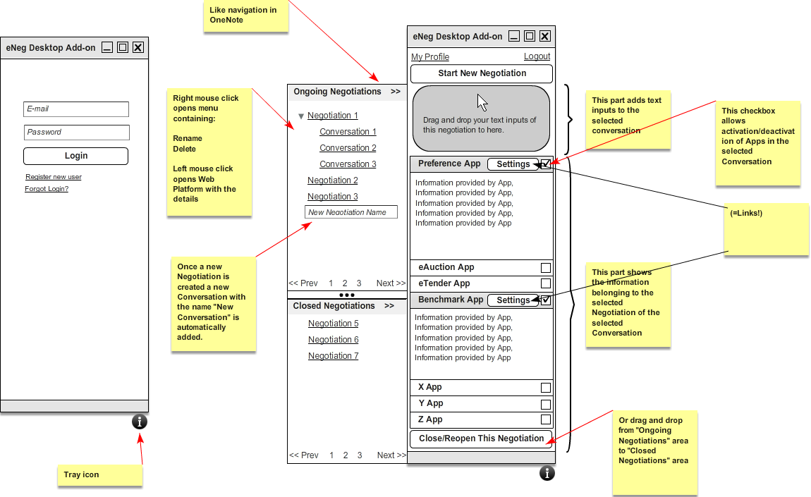

The left screen shows the login window of the eNeg Desktop Add-on. The Add-on can be loaded after installation via click on the system tray (similar to e.g. Skype). Here the user can also register or request his login (direct links to the Web Platform sub-pages).

The right screen shows the navigation which is similar to Microsoft OneNote navigation (left side) where the user can manage his Negotiations and Conversations (Ongoing and Closed). The right side allows the user to edit his Profile (direct link to the Web Platform sub-page) and start new Negotiations as well as add new text to a selected Conversation and manage his Apps for the selected Negotiation.

### Web Platform

### Login, Register, Forgot

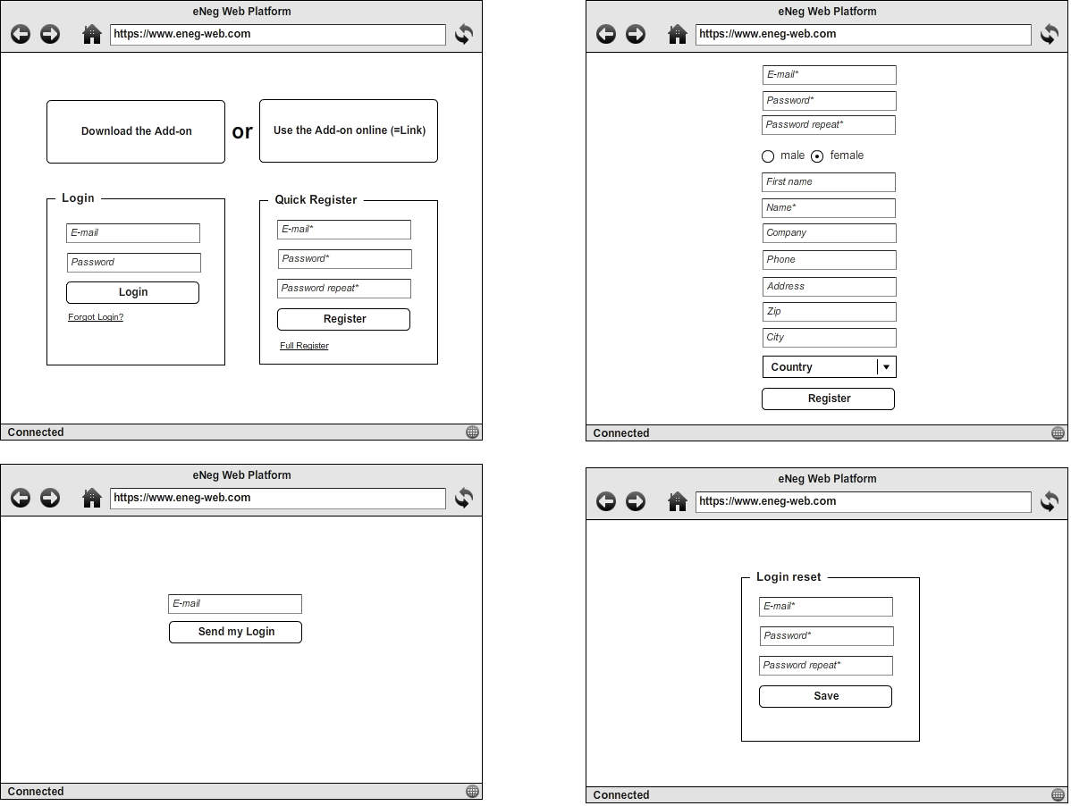

Screen one (top left) allows users to Login to the Platform and execute quick registration. Screen two (top right) shows Full Registration Page. Screen three and four (bottom left and right) show the screens used when Login is forgotten. In this case the user has to enter his registered E-Mail and then an E-Mail is sent with a reset link that opens screen four. All fields marked with * are mandatory fields.

### Negotiations Overview

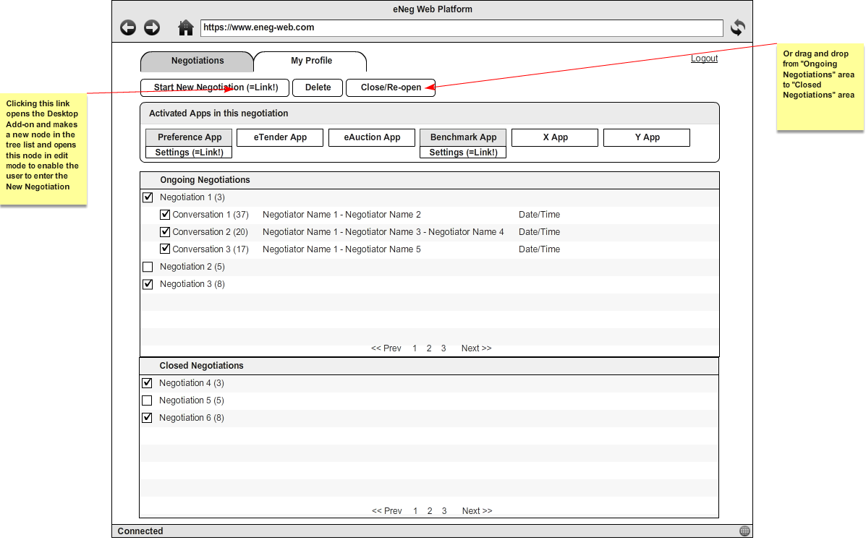

Negotiations overview allows users to see detailed information about Ongoing and Closed Negotiations and its Conversations. From here it is possible to start new Negotiations (direct link to Add-on) and manage them. The installed Apps can also be managed from this page.

### Conversation Details

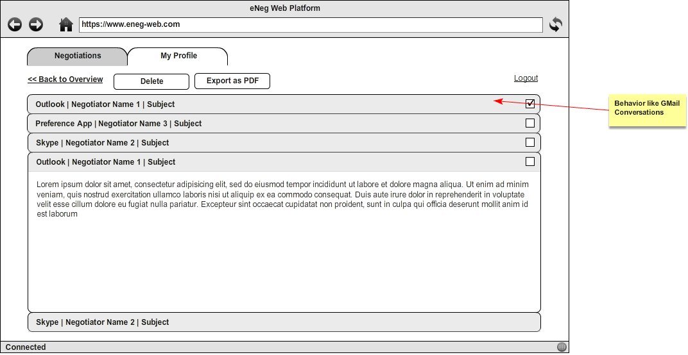

After clicking on a Conversation its Messages are shown with full details. From here it is also possible to export data to PDF. Messages can be collapsed and expanded similar to Gmail behavior.

### My Profile

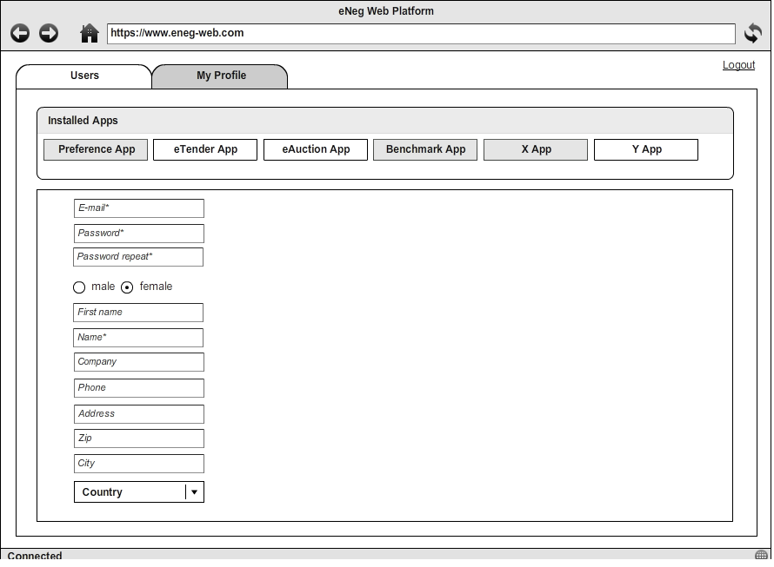

The “My Profile” page allows users to see all installed Apps and to update his own data. In a later phase there will be an App Store where users can install new Apps to their system.

### Delete Message

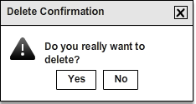

This is a standard Delete Confirmation Message used all over the system.

### Users Overview (Admin)

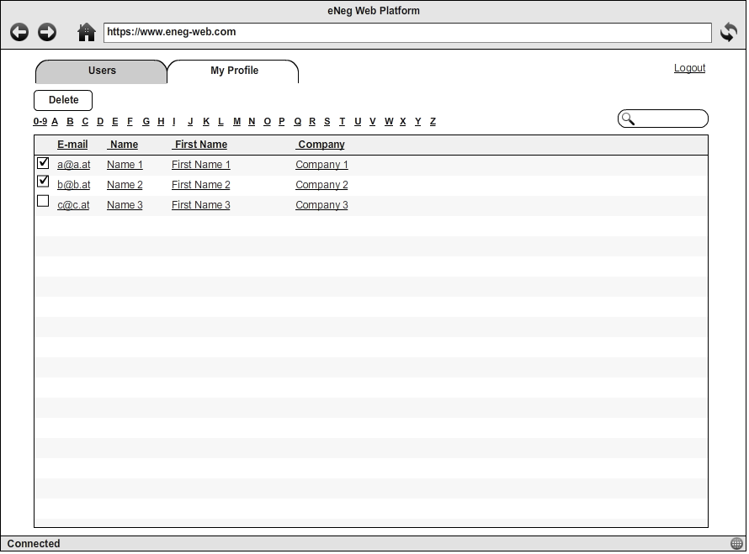

Only Admins can see this page after Login where they can manage subscribed User accounts.

### User Details (Admin)

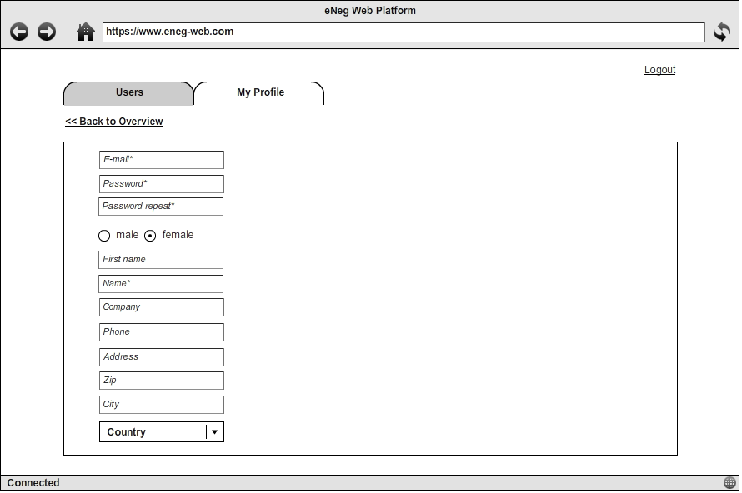

After selecting a specific user only Admins have the right to update User’s data in this screen.

### Preference App

### Login

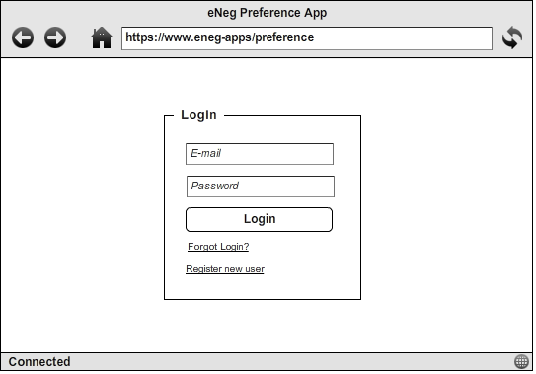

This page allows users to login to the App using the same Account that was registered on the Web Platform.

### Preference Sets

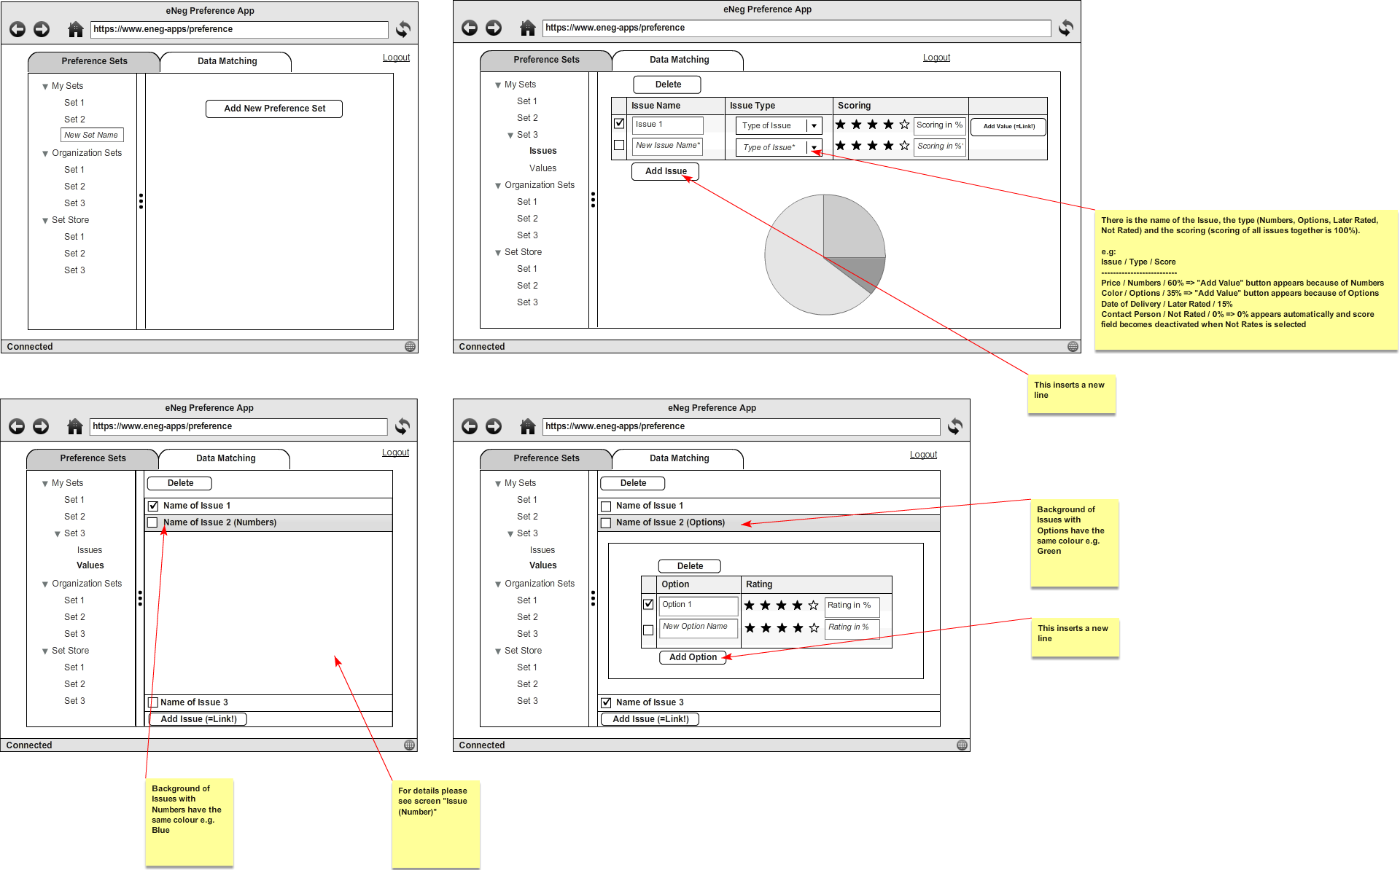

In screen one (top left): The user can add a new Preference Set or select an existing Preference Set. There can be Preference Sets from the User, Sets provided by his organization or Sets provided by the Set Store. The User sees a list of all existing Sets in every of the three categories and he sees the details of the sets when clicking them. He can also edit or delete existing Preference Sets. All inputs and actions are stored on the fly in the whole Preference App.

Screen two (top right): The first step to add a New Preference Set is to add the Issues of the Negotiation. There is the name of the Issue, the type (Numbers, Options, Later Rates, Not Rated) and the scoring (scoring of all issues together is 100%).

e.g: **Issue Type Score**

Price Numbers 60%

Color Options 35%

Date of Delivery Later Rated 15%

To enter the preference curve of an Issue you can click on “Add Value” (direct link to value page including selection of issue) or select “Values” in the tree view.

Screen three (bottom left): The second step is to define the preference curves behind the Issues. The two different possibilities are Numbers or Options, also for a Later Rated Issue. For Not Rated Issues there are no entries at this step.

### Screen four (bottom right): The entries needed to create a preference curve for an Issue of Options are the different Options and their rate.

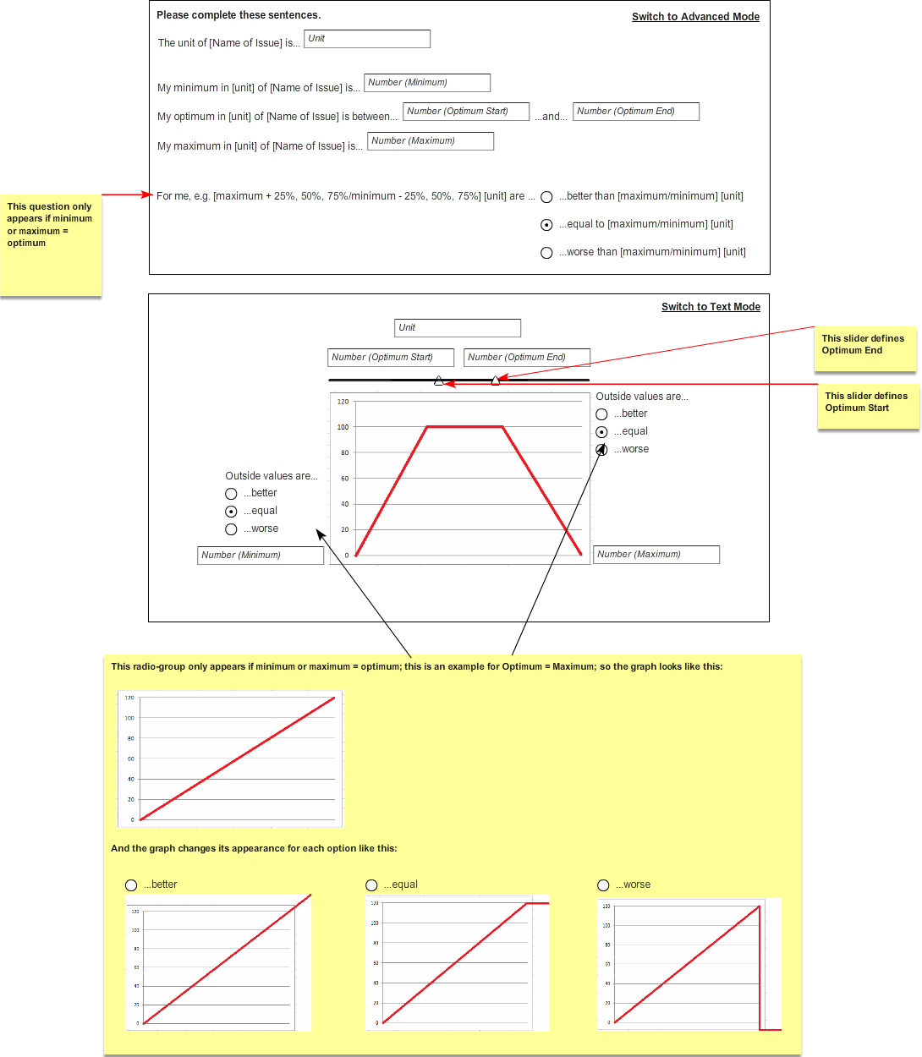

### Data Matching

The data matching page is one of the most critical pages of the system. Here Preference Sets can be linked with Negotiations and all kind of Data Matches are done from here. This is the critical step to receive good support information. The page allows matching Values with Issues easily and simulates possible scores (Score Preview). To allow different User types different ways to interact with user interfaces there is a Drag and Drop Mode (left screen) as well as a so called Classic Mode (right screen) to execute the matching individually.

### Report

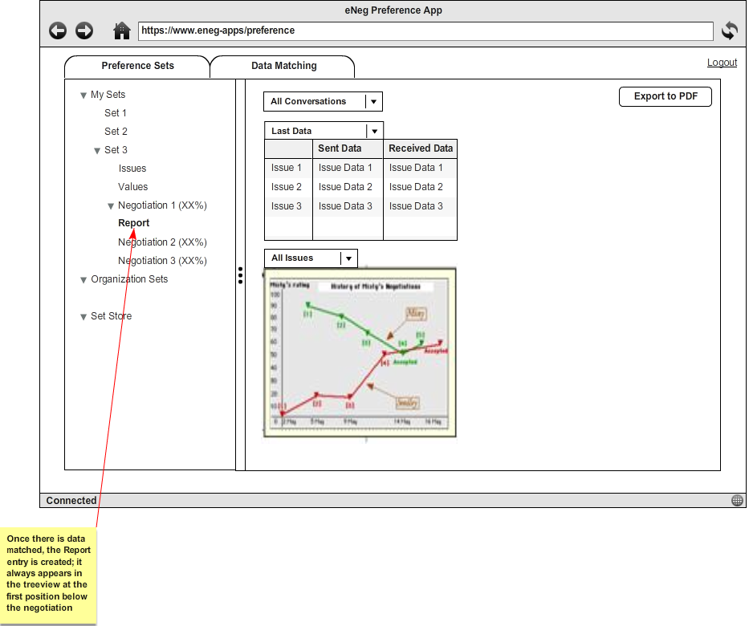

In the report the User got all information about the current state of the Negotiation according to his Preference Set. He can choose between the Conversations, if there is more than one, to see the last offers of him and his counterpart or the best offers (normally it should be the same like the current offer, but it could be, that one of the past offers of the counterpart got more value for the user and in general the first offer of the User himself got the most value for himself). The User can also see a chart of the changes of the offers over time, which is called Negotiation Dance. The User can decide to see the chart for all Issues or for the single Issues one by one.

## Software Interface

API to Apps; currently limited to “Preference App” (to be defined in Technical Design Document)

## Commuication Interface

Required communication protocol is https.

Synchronization between Add-on and Web Platform should be event-based. Once a new text input is drag and dropped to the text inputs area in the Add-on the Web Platform (first) and the App (second) should get the data pushed. On the other hand: once a new App sends a new support message the data should be pushed to the Web Platform and the Add-on.

# Non Function Requirment

## Performance

Performance for the current phase is not too critical as the amount of users in the first phase should be about 100. But it should be considered for later phases to be optimizable and state of the art.

## Safty & Security

Hardware is planned to be hosted externally at a housing provider which provides a good level of security in terms of building access and high availability (power etc.). Used servers will be mirrored and regularly backuped to assure fast recovery and ongoing monitored (updates, protocols, optimizing, etc.) and hardened (configurations, firewalls, vpn, antivirus, etc.) by an expert.

Software should make use of encryption technologies concerning critical data (login) and assure secure communication (SSL) as well as a good role- and rights-system to allow the needed views. Logging of major user activities should be possible to allow more transparency about who did which changes when.

## Scalability

Not critical for the current phase.

# Other Requirements

System design should consider later localization to other languages.

# Next phases’ Outlook

Keyword “CSCW”

In the current scenario only one negotiator uses the FrameWork and enters all data to the system (sent and received) but in a later phase many negotiators should be using it in terms of CSCW (both negotiators enter their own data). This will allow more detailed support in terms of user notifications (such as preferences have changed, best rank lost, new negotiation online, negotiation was canceled, etc.), vice versa preference analysis and optimization, etc.

Keyword “Structuring collected data”

(to be defined)

Keyword “Semi-automation of Negotiation”

(to be defined)